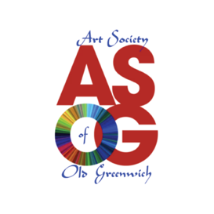
MEMBERSHIP APPLICATION FORM

Name: ______________________________________________________________

Address: ____________________________________________________________

City: ________________________ State: ________________ Zip Code: ________________

Home phone: ________________________ Cell phone: ________________________

Email: _____________________________________

I would like to join/renew membership to ASOG. (Circle one)
ASOG membership expires on December 31, 2023.

Type of Membership:

- Full ($50)
- Student ($20)

________________________________ ______________________________
Signature of Applicant Date

Please mail payment along with this form to:
Art Society of Old Greenwich
P.O. Box 103
Old Greenwich, CT 06870

Questions? Please send an email to news@asogct.com

